STMicroelectronics XBox DVD Player Buttonology

This document describes functionality of the Xbox Gamepad in conjunction with the STMicroelectronics Xbox DVD Player application.

The graphic below defines the various input controls on the Microsoft Xbox Gamepad.
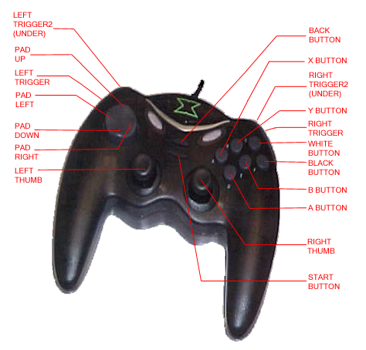

The following table describes how to use the Gamepad to drive the STMicroelectronics DVD player application.

Gamepad Control | DVD Player Action
A Button | Depends on current state:
A Button | State | Action
A Button | Stopped or paused | Resumes playback
A Button | Playing | Pauses
A Button | In DVD menu | Activates current selection
B Button | Stops playback, returns position to beginning of DVD
X Button | Step thru zoom levels (4 levels, mult by 2X each step)
Y Button | Displays root menu
Black Button | Displays Help screen
White Button | Toggles display of current elapsed time
Left Trigger | Plays previous chapter
Right Trigger | Plays next chapter
Pad Up | State |  | Action
Pad Up | In DVD menu |  | Navigates up in a DVD menu
Pad Up | Zoom mode |  | Pans zoom up
Pad Down | State |  | Action
Pad Down | In DVD menu |  | Navigates down in a DVD menu
Pad Down | Zoom mode |  | Pans zoom down
Pad Left | State |  | Action
Pad Left | In DVD menu |  | Navigates left in a DVD menu
Pad Left | Paused DVD playback |  | Frame Reverse
Pad Left | Normal DVD playback |  | Play previous chapter
Pad Left | Zoom mode |  | Pans zoom left
Pad Right | State |  | Action
Pad Right | In DVD menu |  | Navigates right in a DVD menu
Pad Right | Paused DVD playback |  | Frame Forward
Pad Right | Normal DVD playback |  | Play next chapter
Pad Right | Zoom mode |  | Pans zoom right
Start Button | State |  | Action
Start Button | In DVD menu |  | Resumes playback
Start Button | Paused or stopped playback |  | Begins playback
Back Button | If in DVD menu, returns or ‘goes up’ to previous menu
Left Thumb | If zoomed, pans zoom region
Right Thumb | Vertical movement zooms in(stick up) or out (stick down)  Horizontal movement jogs forward/reverse
SHIFT+A Button* | Displays Audio menu if more than one audio stream available
SHIFT+B Button* | State |  | Action
SHIFT+B Button* | Playing |  | Steps thru various fast forward scanning speeds (1.25x, 1.5x, 2x, 10x, 20x)
SHIFT+B Button* | Paused |  | Steps thru various slow forward scanning speeds (0.25x, 0.5x, 0.75x)
SHIFT+X Button* | State |  | Action
SHIFT+X Button* | Playing |  | Steps thru various fast reverse playback speeds (1.25x, 1.5x, 2x, 10x, 20x)
SHIFT+X Button* | Paused |  | Steps thru various slow reverse playback speeds (0.25x, 0.5x, 0.75x)
SHIFT+Y Button* | Displays Subpicture menu if more than one subpic available
SHIFT+Black Button* | Displays Dolby settings menu
SHIFT +White Button* | Displays Angle menu if more than one angle available
SHIFT +Left Trigger* | Decrements volume
SHIFT+Right Trigger* | Increments volume
SHIFT+Start* | Displays Title menu if one exists
SHIFT+Pad Left* | Drop a bookmark
SHIFT+Pad Right* | Display menu of bookmarks if any exist

* SHIFT is performed by holding in the Left Trigger2 underneath the gamepad.

